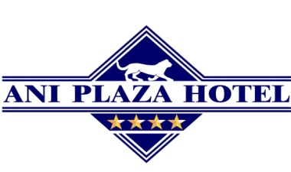

Reservation Form

Please complete the form in its entirety, including all requested documentation and send it to reservation@anihotel.com or reservation@anihotel.am with a copy to sales@anihotel.am and you will receive a reservation confirmation.
This reservation form enables participants of the EPRA October Meeting to use special room rates (you can find below) in Ani Plaza Hotel. Registration deadline is until September 09, 2016. Guaranteed reservations can be cancelled without any charge no later than 7 days prior to arrival date. Cancellations made later imply penalty equal to the first night room rate.

Today’s Date: _______________

I, ___________________________________________________________, authorize use of my credit card for full payment of Room.

Name, Surname

Room Type
Number of rooms required
Arrival Date/Time
Departure Date/Time
Telephone Number
E-mail Address

Credit Card
VISA/MASTER/AMEX
Credit Card Number

Expiration Date

Name on Card

Cardholder Signature

19 Sayat-Nova Ave., 0001, Yerevan, Republic of Armenia, Tel.: (+374 10) 594 500
E - mail: sales@anihotel.am, reservation@anihotel.am, reservation@anihotel.com www.anihotel.com

Room types

Category | Season
Single | 36,000
Double/Twin | 44,000
Ani King | 49,000
Junior Suite | 52,000

Ani King Double | 53,000
Junior Suite Double | 56,000

- Above Rates Include
  - Full Buffet Breakfast
  - VAT 20%
  - Wi-Fi Internet
  - Swimming pool, sauna and gym
- Check-in Time Is 14:00
- Check-out Time Is 12:00 Noon
- Airport Transfer is available for a fee upon request
- Registration deadline is until September 09, 2016

All categories include swimming pool, sauna and gym, except Single and Double/Twin rooms

